HOW TO APPLY
STEP 1
"If you already have an account then Login Otherwise you need to make a new account so click on “Sign Up”.
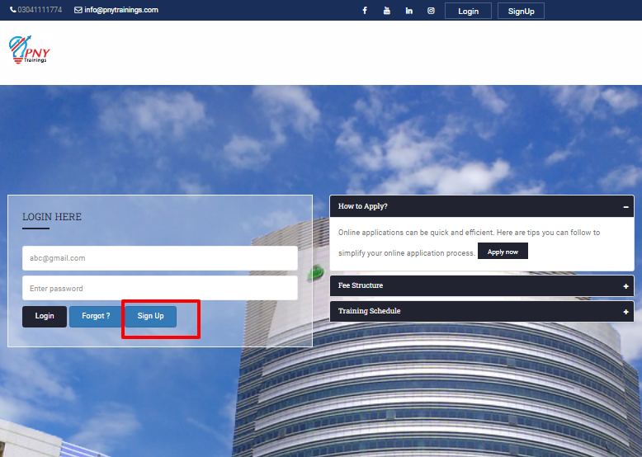
STEP 2
- Select “Local” if You are from Pakistan otherwise if you are foreigner select “Foreign”.
- Complete all necessary fields and tick on the checkbox after reading “Terms & Conditions” and then click on the Apply Now button.
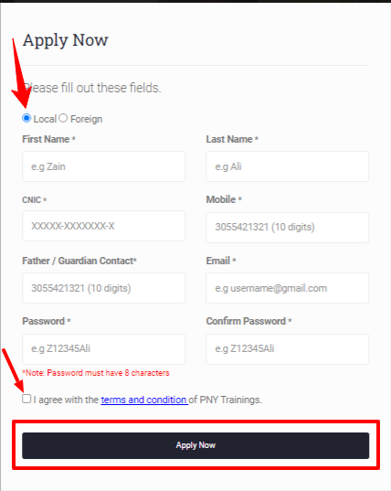
STEP 3
After creating your account enter your Email and Password to login.
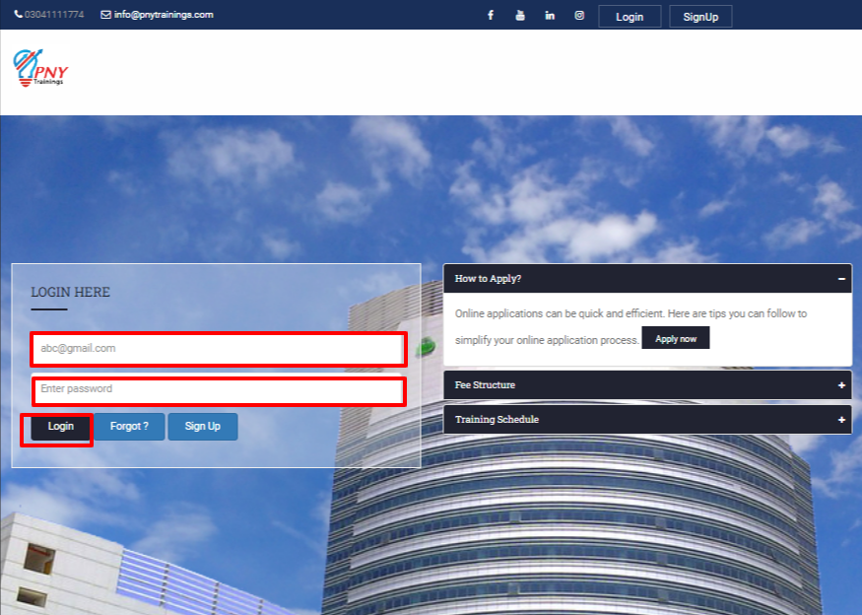
STEP 4
After logging in your account click on “Submit New Application”.
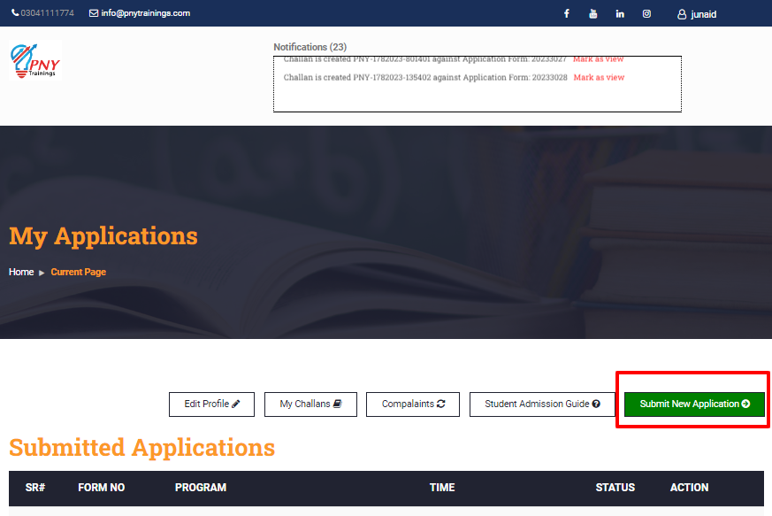
STEP 5
After that select Institute, select the desired programs you want to enroll in, then select the Batch and then click on Continue.

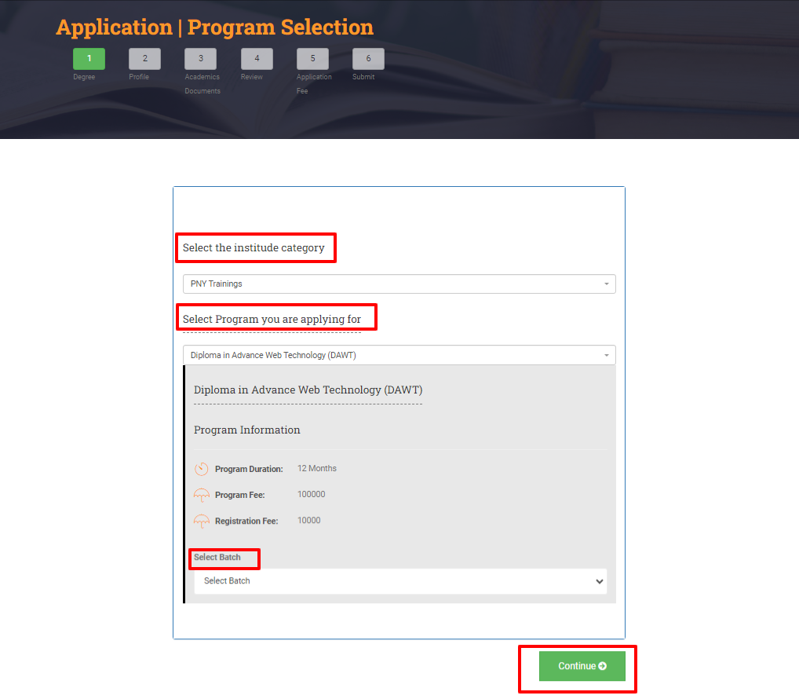

Step 6
In the next step fill the complete form and add your personal details and then click on Continue.

Step 7
In the next step add your “Academic Documents” and click on next.

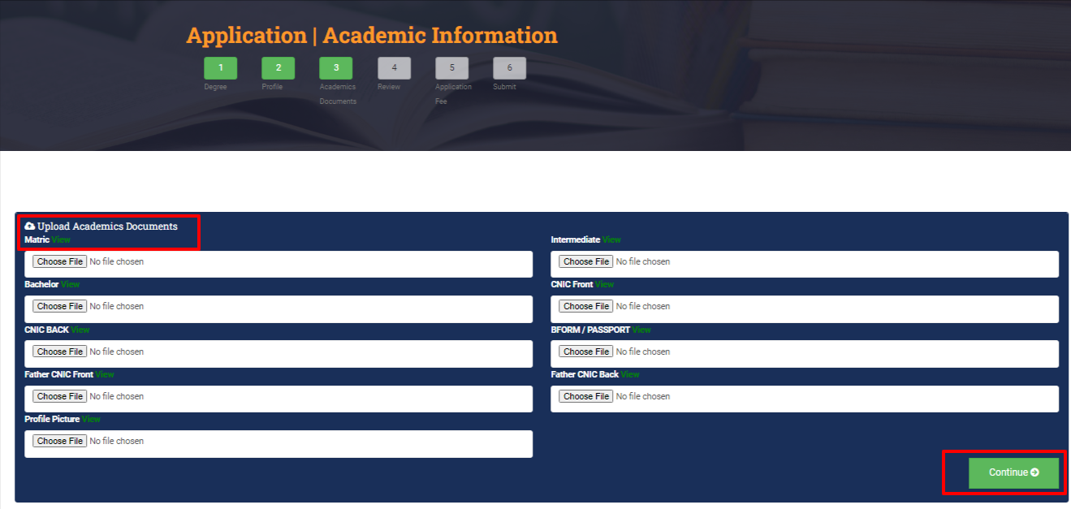
Step 8
Preview all your details carefully and click on Continue.
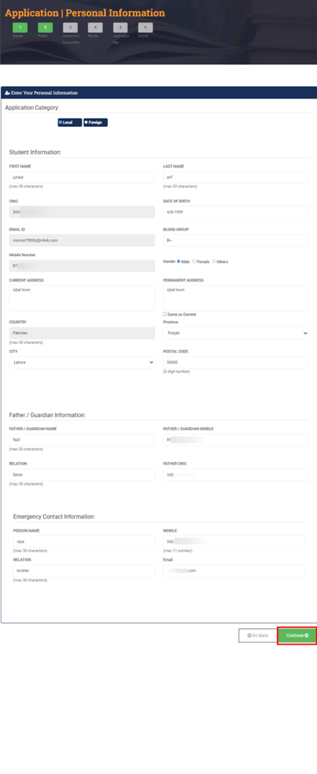
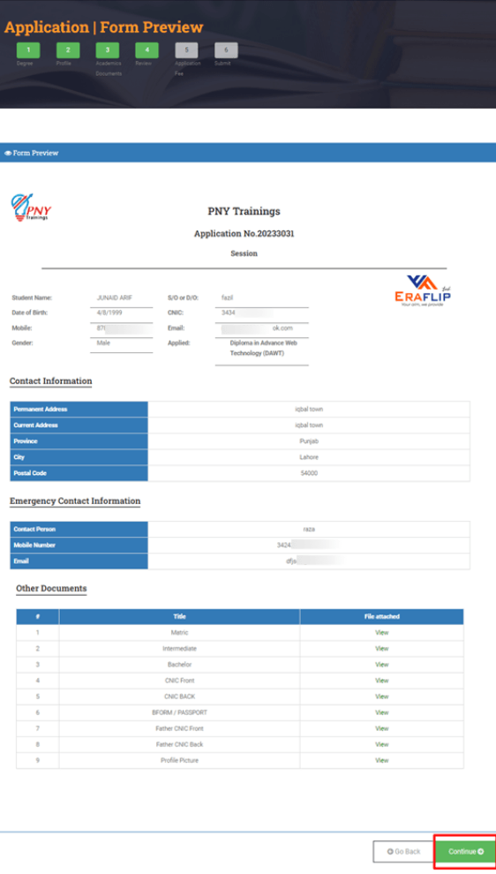

Step 9
Add voucher code if you have then click on “Apply” after that Download Challan Form.
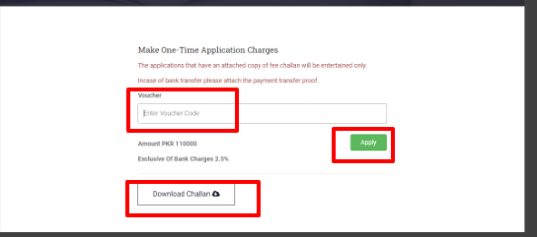
Step 10
In the next step click on “Pay Online”.
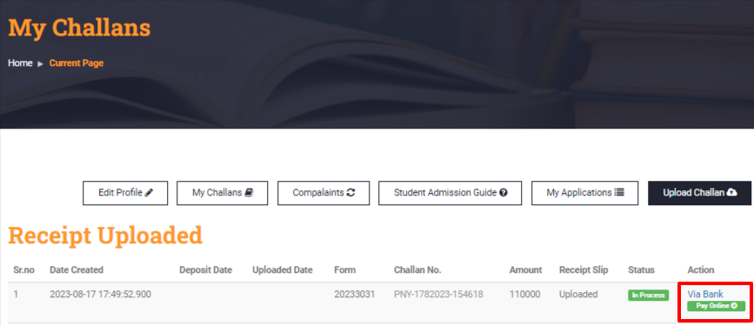
Step 11
Choose your payment method by which you want to pay, fill the details and pay the required payments. After paying a message will be appear “Your Transaction Status”as shown in the picture below take a screenshot of that message.

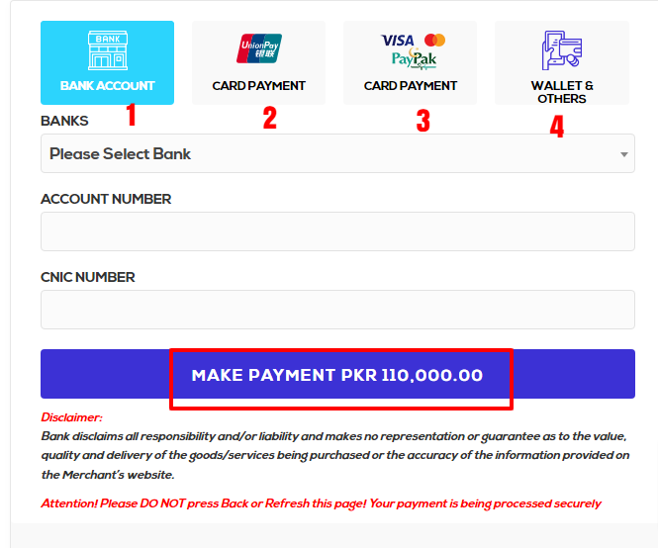
Take Screenshot of this message.
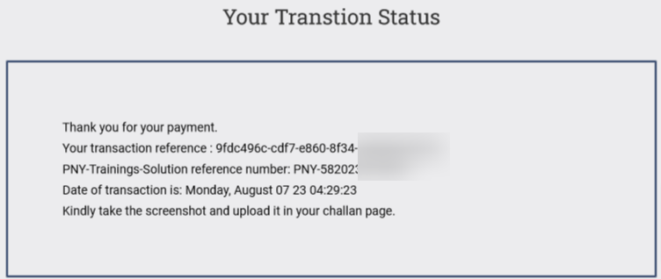

Step 12
After that click on “Upload Challan”
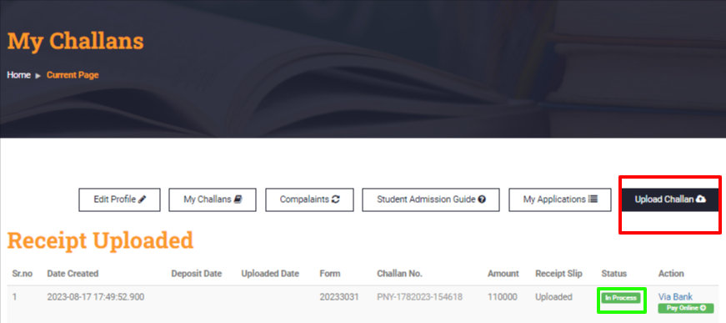
Step 13
When you click on “Upload Challan” You need to write “Invoice No. (Reference No Given in Transaction status Screenshot). Select Payment method by which you paid the payment upload the screenshot you have taken fill all the fields accordingly and then click on submit.
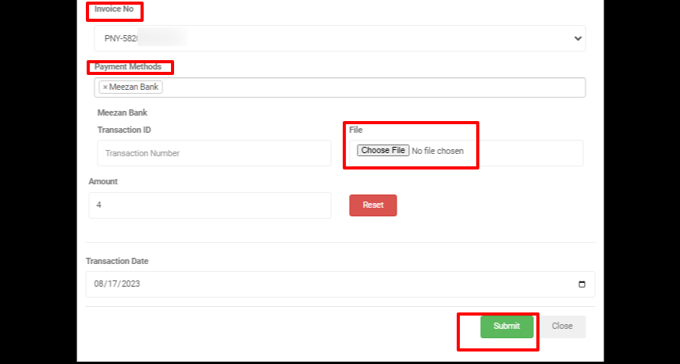

Step 14
After verification your application status will be Verified and our team will contact you within 24 hours.

